What is a Response Journal?

Journals provide learners with an opportunity to record their personal thoughts, emotions, ideas, questions, reflections, connections, and new learning on what they hear, view, read, write, discuss and think.

“What we as educators want is that their writing enable students to personalize a story and gain insights about the character, to help them reflect, and to help them see the world in a different way.” (Brownlie, 2005)

“Our reflections are the making of deeper meaning and richer understandings. Our reflections are our dreams, our ideas, our questions, our initiatives, our visions – our journeys of lifelong learning and teaching.” (Schwartz & Bone, 1995)

Why are Response Journals an effective reading strategy?

Response journals allow the students to “remember to hold on to their thinking” about what they are reading. (Zimmermann, 1997)

Response journals are easily implemented at all levels. They can be used to target specific outcomes of the Provincial ELA Curriculum.

Response journals can be used with any genre of literature (poetry, short stories, media text, novel studies) and in different content areas that use expository text.

When should Response Journals be introduced?

Response journals should be introduced as soon as possible using scaffolding such as sentence frames or prompts to start. The goal should be to have students enter the middle years feeling comfortable with recording their responses to reading with little or no scaffolding.

How can I ensure student success?

Choose poetry, stories or books with enough depth to elicit responses.
Students should have the opportunity to discuss the reading before ever being asked to write a response. Use of the “Say Something” strategy (Brownlie, 2005) creates an atmosphere of acceptance and trust.
Modeling, scaffolding, building criteria with students and practice with feedback are the most important tools for improving the quality of responses.
Scaffolding is the use of a variety of starters, frames and graphic organizers to allow students to develop thoughtful responses. If needed, open ended prompts may be used for some students. (See Appendix)
Modeling is critical to the success of student journal writing. Teachers need to model their thinking about a selected piece of text and how that thinking can be used to form a written response. This needs to be done regularly throughout the year with a variety of texts and responses.
Students require frequent practice in the various forms of journal writing. The teacher must provide feedback based on criteria that has been developed with the students.
This practice with feedback allows students to monitor their growth and set goals for future journal responses.

What are the different formats for Response Journals?
(See Appendix for examples)

1. Double Entry Journal
This is the most common response journal. The page is divided in half lengthwise. One side refers to a specific piece of text in the form of a quote or a summary. The specific text may target a literary strategy, technique or element of the author’s craft. It may also elicit a personal response such as a connection, feeling or opinion. The other side targets the students’ thoughts regarding the selected piece of text.

2. Diary Entry
In this style, the student writes from the point of view of one of the characters. It should include what the character might be thinking or feeling.

3. Illustration
Students draw or illustrate a specific scene using thought bubbles or captions to show the character’s thoughts and feelings or demonstrate the scene’s importance. (Brownlie, 2005)

4. Interview
The student makes up questions they would ask one of the main characters. The questions are answered in the characters “voice”.

5. Letter
There are many options in this response. Students may write a letter to a character, to the author, to the teacher, to a friend, to another student. In the letter they are asking questions or sharing ideas about what they have read. At times, certain letter types could be responded to in the same fashion as a Dialogue Journal.

6. Dialogue Journal
Students reading the same novel work in pairs. They write a reflection to their partner in response to the novel. The following day, they exchange journals and write back to their partner. (Brownlie, 2005)

- Graphic Organizers
Graphic organizers such as KWL Charts, Mind Maps, Venn Diagrams, Timelines,
Bar & Line Graphs are used to assist students in constructing meaning from text.

- Coding the Text
There are a variety of coding techniques including the use of stickies or highlighting to target specific elements of text such as vocabulary, figurative language, and confusing parts of text, questions and memorable quotes. If specific letter/symbol codes are being used, they should be developed in collaboration with your students and clearly posted in your room.

How do I assess my students’ journal responses?

Teachers assess for content not conventions. Students must be part of the criteria setting process. This will enable students to set clear and realistic goals.

Teachers may choose to examine journal entries as evidence of student writing at the draft stage. However, this does not mean that students cannot choose one of their responses to take through the writing process and publish at a later date.

How do I build and use criteria with my students?

Criteria are the standards by which something can be judged or valued. When we determine these criteria, we are deciding what counts. Teachers set criteria with their students. When students are involved in developing criteria, they are much more likely to understand what is expected of them, “buy in”, and then accomplish the task successfully.

A four step process for setting criteria with students encourages student participation, understanding and ownership. The first three steps should be carried out before or as students are beginning their project or assignment.
- Brainstorm
- Sort and Categorize
- Make and Post a T-Chart
- Add, Reuse, Refine
For further information on setting criteria, refer to Setting and Using Criteria. Copyright 1997. Kathleen Gregory, Caren Cameron, Anne Davies, Connections Publishing.

How do I tie the Reading Continuum descriptors to my students’ journal responses?

At every level of the continuum, there are descriptors that can be assessed by some type of journal response. For example, at the Expanding Level students should be able to “express opinions with evidence from the text”. In the journal response, the teacher should be looking for opinions supported with evidence from the text. The teacher should see evidence of this at least three times before noting this skill on the reading continuum.

APPENDIX

i. JOURNAL PROMPTS

Book Title Nov. 2, 2002


- Tell about what happened in the story.
- Ask questions about things that confuse you or that you wonder about.
- Describe your feelings about the events.
- Describe your feelings about characters.
- Copy down a quote from a character and tell why you think it’s meaningful.
- Describe your favorite part.
- Make a prediction about what will happen next.
- Tell how you would react if you were one of the characters in the story.
- Describe a part that surprised you.
- Does the author use any strong imagery in the story (similes, metaphors, etc.)? Give examples.
- Write a letter to the author or a character.
- Draw pictures or create graphic organizers.

Adapted from Grand Conversations, Thoughtful Responses. Copyright 2005. Faye Brownlie. Portage & Main Press

JOURNAL PROMPTS

Summary |   Personal Response | Think Questions | Vocabulary –  Page # and New Word
- Main idea  - Beginning  Middle  End  - Characters  Setting  Problem  Solution  - Important events or information  Author’s  and how  use it | - Like or don’t like  - Agree or don’t agree  - Favorite part or  favorite character  - Prediction  - Connection to life  - Compare to another  Story  Message  I can  in my life | - Why?  - How?  - What would happen if?  - I wonder | - Lőők In  - Lőők Around  - Lőők It Up  Language  - Awesome adjectives  - Vivid verbs  - Precise nouns  - “Show not tell”  - Similes  - Other “powerful  language”

Balanced Literacy Instruction. Copyright 1997. Kathryn H. Au, Jacquelin H. Carroll, Judith A. Scheu, Christopher-Gordon Publishing Inc

- DOUBLE ENTRY JOURNALS

What’s Happening | My Thinking
Brief Summary  Key events/facts/details  Key Quotations  Themes  New Vocabulary  Confusing Part | Reader’s reaction/opinions supported with evidence from the text  Why they’re important/What’s the author’s message?  My thinking/interpretations about the meaning or significance  Text reference/In my head reference  What I know about the word/how it connects to the text  What I did to get unstuck

Adapted from Grand Conversations, Thoughtful Responses. Copyright 2005. Faye Brownlie. Portage & Main Press

DOUBLE ENTRY JOURNALS

What’s important or interesting to me | Author’s message (what is the author trying to say?)

I Read It But I Don’t Get It. Copyright 2000. Cris Tovani. Stenhouse Publishers.

- ILLUSTRATION

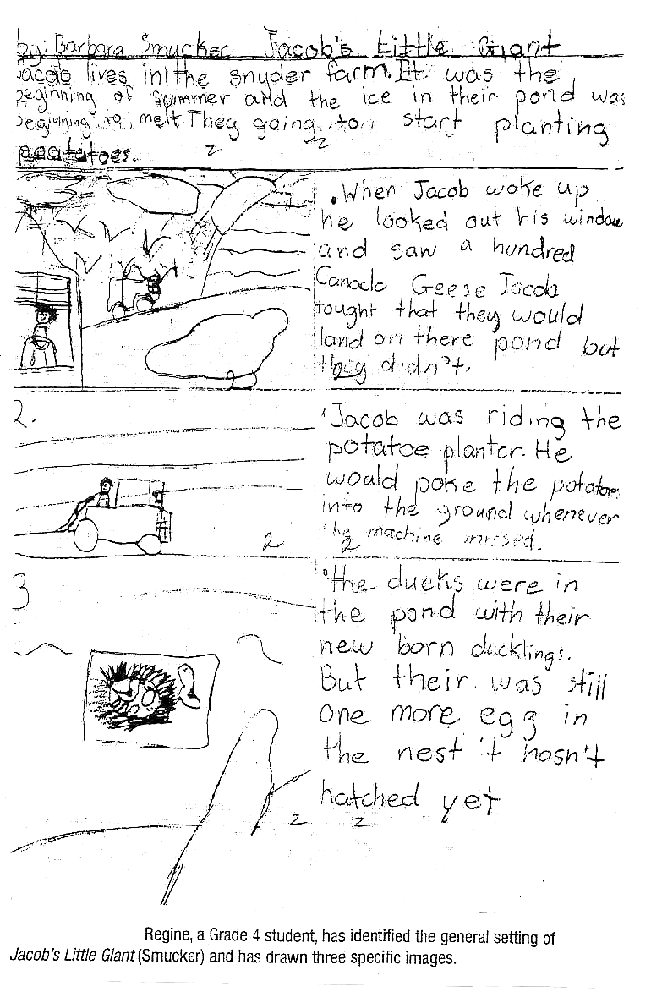

Grand Conversations, Thoughtful Responses. Copyright 2005. Faye Brownlie. Portage & Main Pres

- DIALOGUE JOURNAL

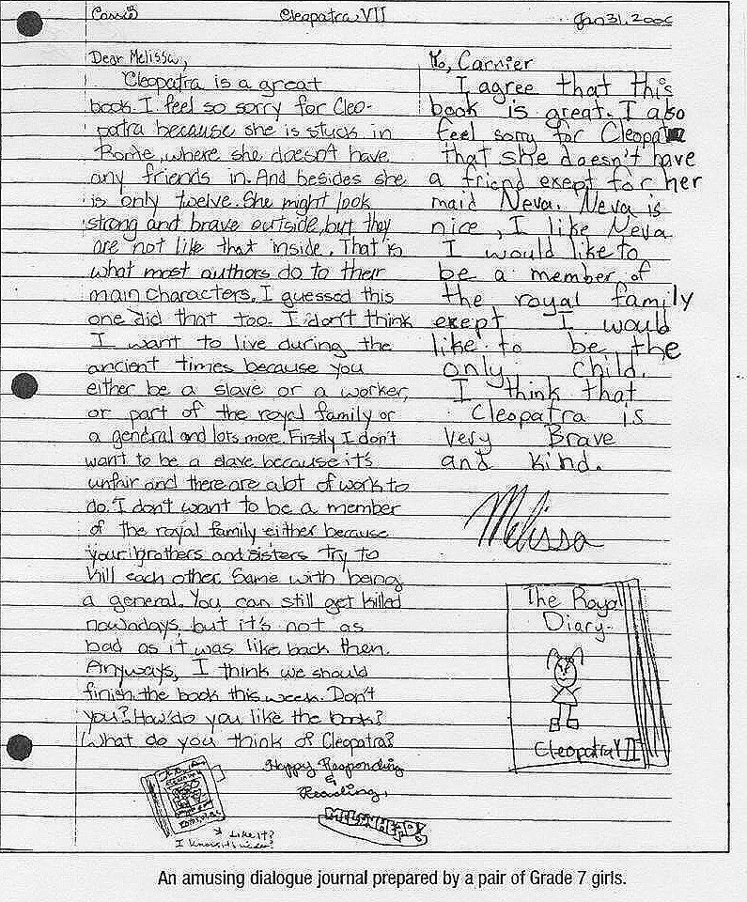

Grand Conversations, Thoughtful Responses. Copyright 2005. Faye Brownlie. Portage & Main Press

DIALOGUE JOURNAL

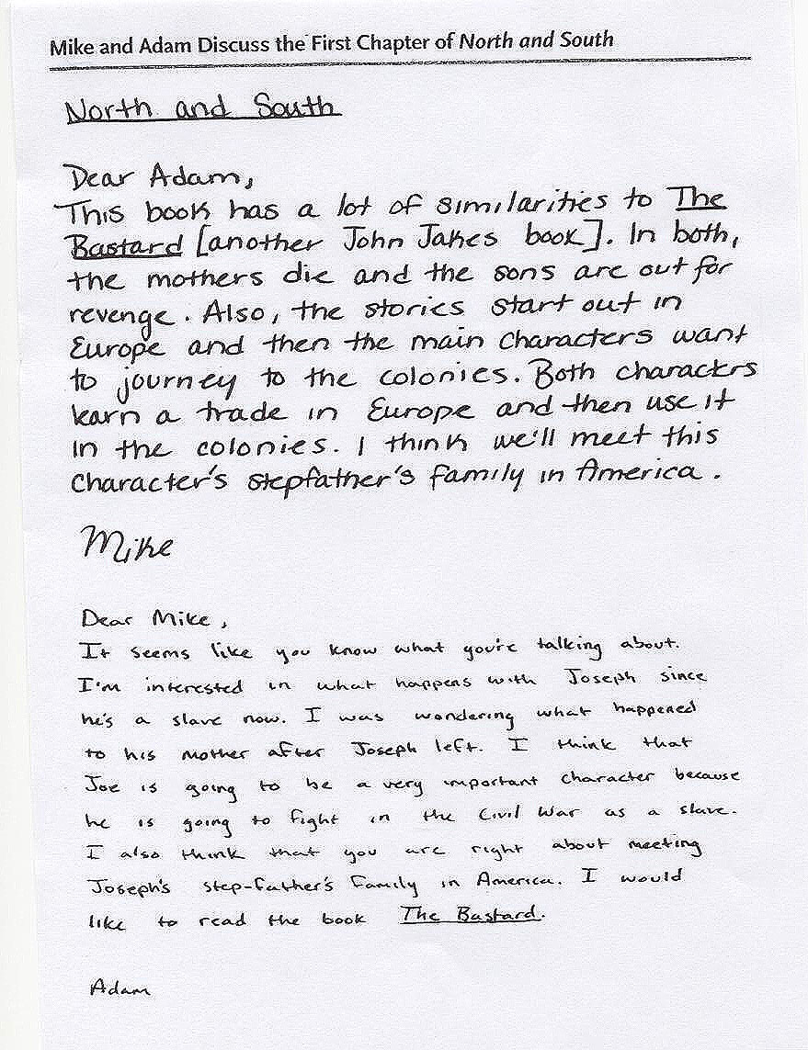

Mini Lessons for Literature Circle. Copyright 2004. Harvey Daniels and Nancy Steineke. Heinemann Publishers.
- GRAPHIC ORGANIZERS
Check the Blackline Masters of the ELA Curriculum Guide
Check the Reading Strategies – At A Glance Document

- CODING THE TEXT

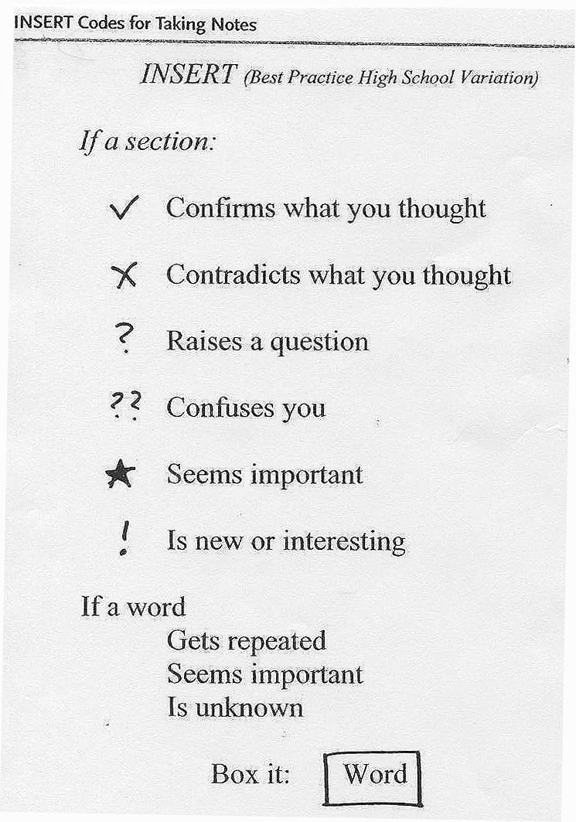

Adapted from Grand Conversations, Thoughtful Responses. Copyright 2005. Faye Brownlie. Portage & Main Press

